Web Design: Project 3 documentation

**Submitted portfolio must include:**

* A URL via blackboard
* .zip file of all assets, images and code used
* Txt file citing all references, code, images, template used
* **Evidence of client scope research**
* **Design iterations and progression**
* **Evidence of flowchart + wireframe / priority guide**
* Peer review sheet submitted via blackboard

**Design and inspiration:**

Out of HTML5up! Bootstrap and WordPress, we chose HTML5up as we were more comfortable using HTML and CSS than bootstrap’s class system and found WordPress to be too restricting.

Once we had chosen this, we browsed a series of different HTML5up! Templates to find what we liked or disliked in a template website. I (Cameron) personally prefer choosing the template first and wireframing later so that I can visually plan out my ideas and get an idea for how I want things to be located. The wireframe is more a means of drawing out the necessities to be built on and rearranged.

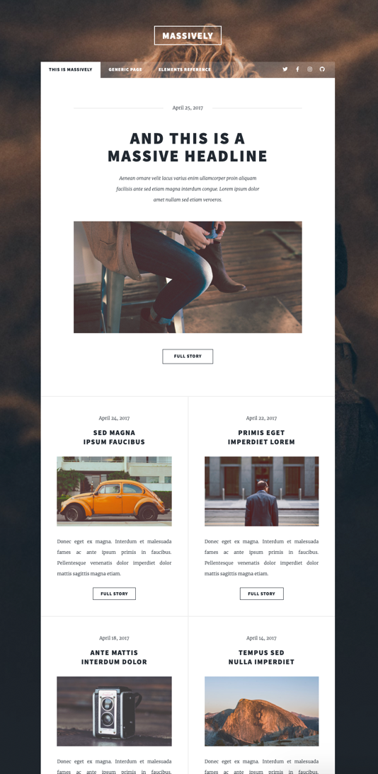

Massively is the first template we looked at and would ultimately be the one we chose. We really liked how clean and concise the homepage looked with its tiled layout.

What’s more, the template already fit a requirement for having multiple means of navigation.

Just looking at the site, I was able to mentally place the different required categories for two separate tours, rentals and a potential fourth category should we finish the other two.

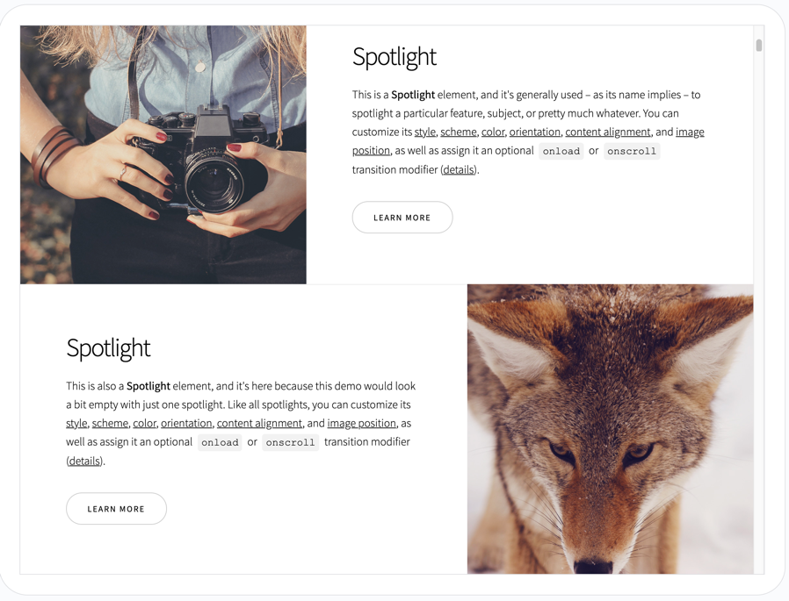

Spotlight was almost as appealing as Massively, but we disliked the bloggier style and how spaced out the information was.

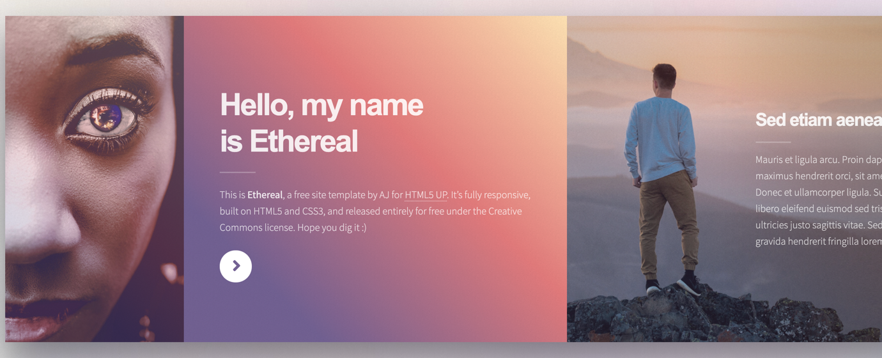

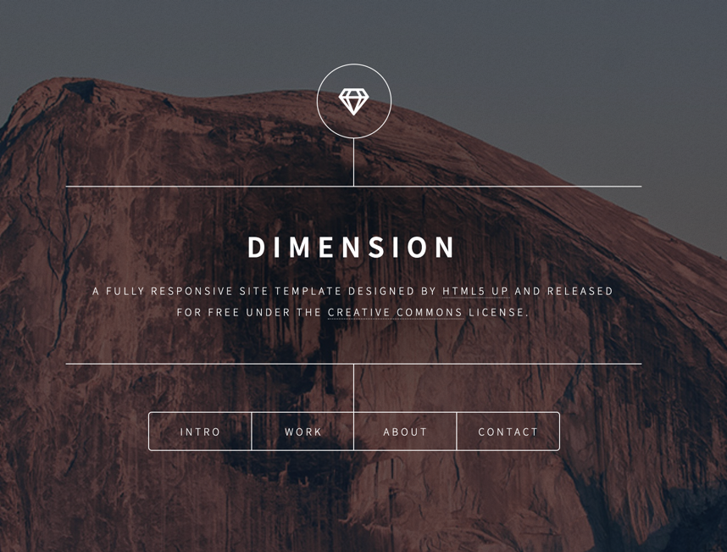

Ethereal and Dimension were both single page websites. Ethereal felt too linear to use. The need to scroll through the entire website to find what you wanted was not user friendly.

Dimension looked very aesthetically pleasing, but was more befitting of a portfolio, rather than an informative business website.

Thus, we decided on Massively as the base for our website.

With the method and template decided on, we set up a joint GitHub project as a means of version control. Further, I created three different branches on top of the main master branch so that each group member could work on their own list of requirements without potentially adversely affecting the others. Then once everything had been completed, I would merge them all back into one.

**Client Scope, User Considerations and Requirements:**

* User needs + requirements
* Client needs + requirements
* How does that fit the structure?
* Which LATCH to use? (Location, Alphabet, Time, Category, Hierarchy)

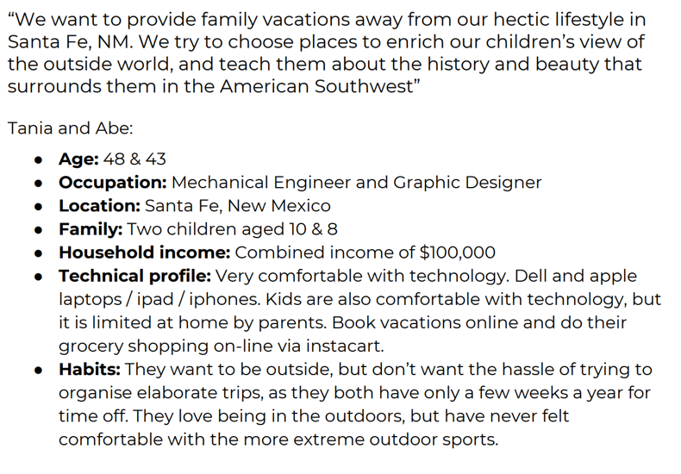

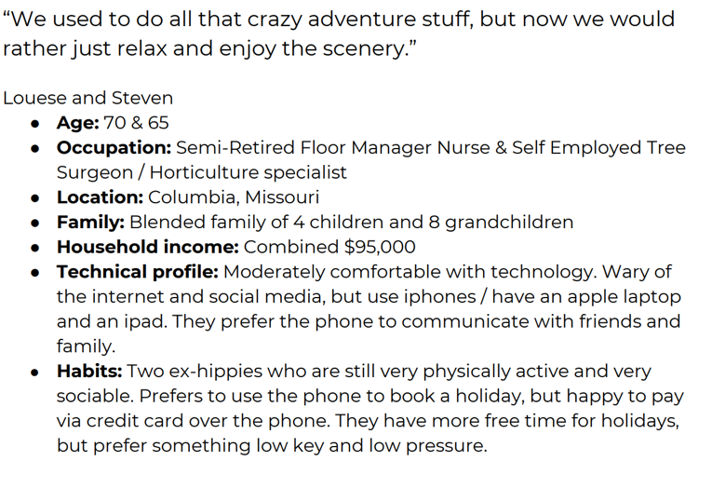

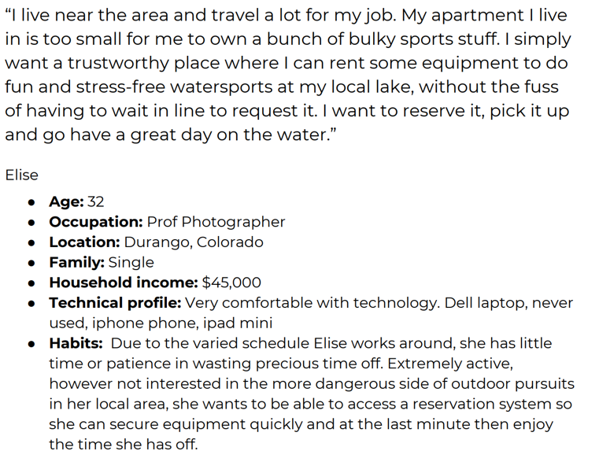

For navigation, we will use a mixture of hierarchy and alphabet.

Home will come first, followed by Durango Tour, Mesa Verde Trips and Rentals.

These four are the most important must have pieces of content.

Following these four will be Gallery. This is not required but will help attract photographer clients, or simply provide an additional incentive to visit the locations.

User needs:

* Information and eye-catching images regarding the different tours and rentals. Information and images should provide a feeling of adventure, exploration and the outdoors.
* Rentals should allow for booking at specific times. Not just form based, rentals need to have phone contact for on the fly renting.
* Contact information.
* Location.
* Easy to use layout and obvious navigation.

Client needs:

* All of the user needs plus a payment method.

**Flowchart and wireframes:**

Home page



Durango Tour

Mesa Verde Trips

Rentals

Gallery



All pages are accessible from the other pages. Gallery will use the tile system. Tours and rentals will use the same text – image – text – form layout. All share form + contact footer.

